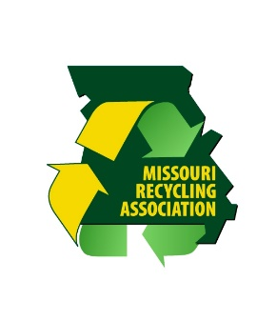
Missouri Recycles Day 2017

Proclamation by the Governor of Missouri Establishing
November 15, 2017 as America/Missouri Recycles Day

Whereas, the State of Missouri recognizes the importance of protecting and preserving our natural resources and adopting responsible habits that will bring about a healthier, cleaner, safer and more sustainable state in which to live, work and play; and
Whereas, participating in America/Missouri Recycles Day 2017 is one way citizens can help raise awareness about the need to reduce waste by re-imagining, re-purposing, reusing, reducing, recycling, and most importantly, buying recycled-content products; and
Whereas, it is important that all Missouri citizens become involved in recycling activities and learn more about the many recycled and recyclable products available to them as consumers; it is also fitting to celebrate Missouri Recycles Day 2017 and take action by engaging all citizens to participate in the recycling options available in our communities; and
Whereas, to focus the state’s attention on the importance of recycling, individuals have joined together to celebrate America/Missouri Recycles Day and are encouraging their friends, neighbors, and coworkers to pledge to learn more about options in their community and commit to buying recycled-content products; and
Whereas, state and community leaders can help encourage recycling by informing citizens about local recycling options, they can also foster greater awareness of the need to expand collections programs by promoting the benefits of recycling, encourage recycling infrastructure and business development; and Now, therefore, I____________, do hereby recognize November 15, 2017 as America/Missouri Recycles Day.

