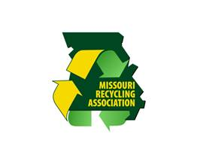
JOIN THE MISSOURI RECYCLING ASSOCIATION
P.O. Box 2144
Jefferson City. MO 65102
1-866-667-2777
Membership Levels
Level: Amount:
Associate $150
Leader $1,000
Sustainer $2,500
Partner $5,000
WWW.MORA.ORG
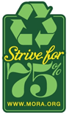

MEMBER BENEFITS
- Access to market information, technical assistance, resources, and
on-line membership directory
- Legislative watch updates and recycling news. MORA is actively promoting aggressive resource management policies
- Exclusive networking opportunities through our annual conference and membership forums
- Membership in Keep America Beautiful (KAB) and the National Recycling Coalition (NRC),
our national partners offering competitions, grants, programs and educational resources.
- Emessages with timely news and training opportunities
- And much more……..
MEMBER INFORMATION

Name | Title

Business|# of Employees

Billing address

City, ST | Zip Code

Ofc Ph|Cell Ph|Fax

Email | Website

PAYMENT INFORMATION
☐Check Enclosed ☐Please send Invoice ☐Payment by Credit Card (below)

Name on Credit Card

Credit Card Number| Exp. Date

Billing Zip Code | 3 Digit Sec Code

Email Receipt to:

Missouri Recycling Association Mission: To lead Missouri toward environmental sustainability through waste reduction and recycling.

